To create Hashmap and list of properties sample

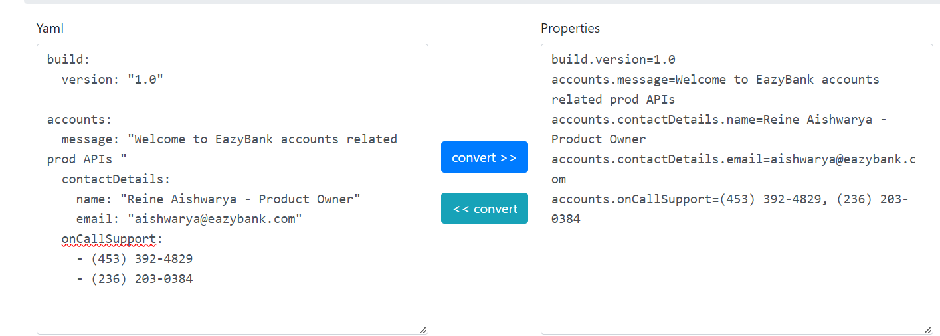

Here contactdetails will create hashmap with keys name and email. And onCallSupport will create a list by default these values are comma separated. We can add different delimiters for that in java we need to annotate with @delimiter annotation

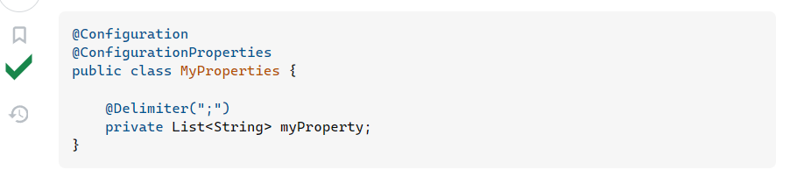

For above properties respective java file

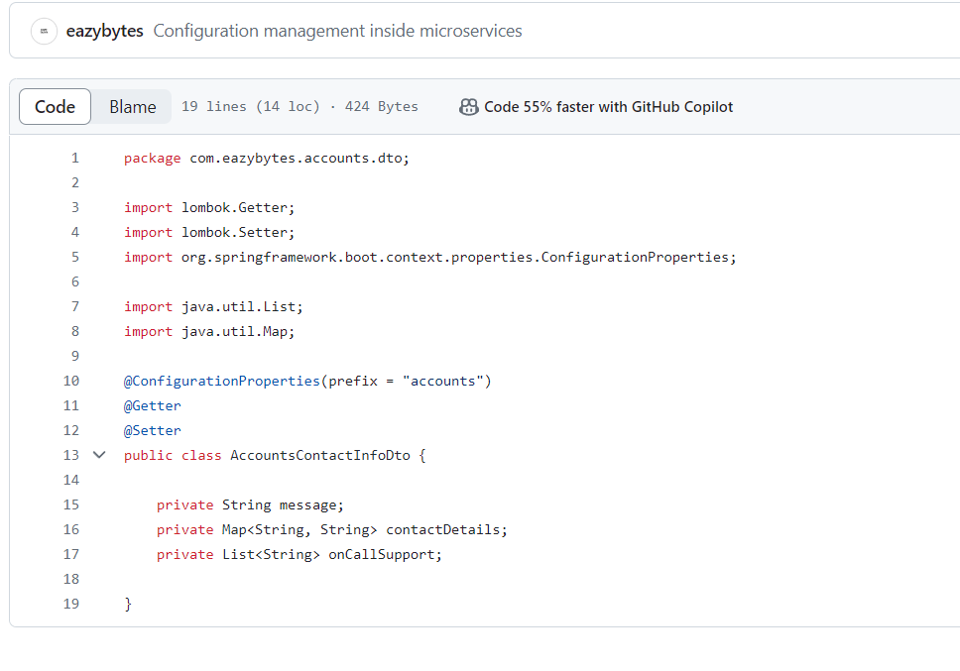

For the list of objects

